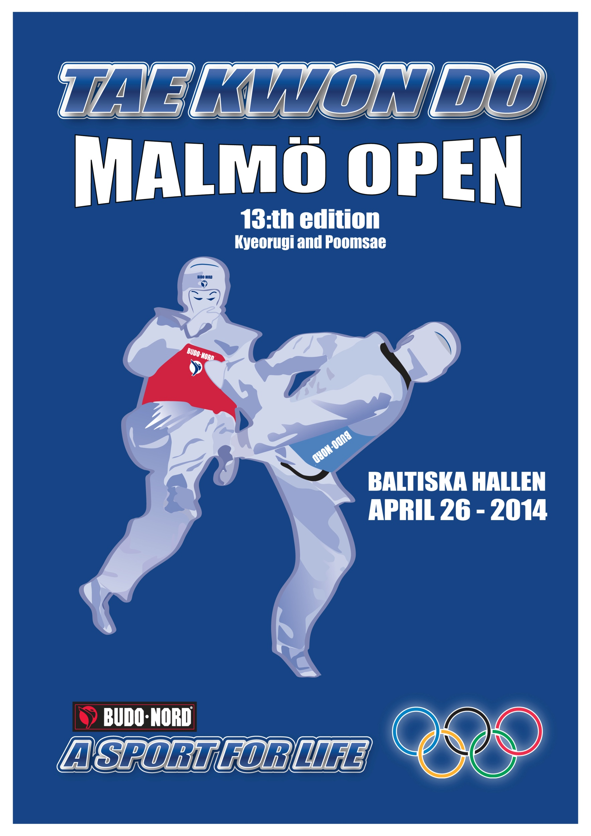

Welcome to Malmo Open 2014
For the thirteenth consecutive year, we wish you a warm welcome to the biggest and best one-day competition in Sweden. Last year we had 700 competitors.
Budo Nord
is the official sponsor and there will be sales and embroidery in place. You will have the chance to buy equipment for great prices.
The competition consists of Kyeorugi and Poomsae:
Both beginners and advanced are welcome.
You can compete in the following classes Miniors, Cadets, Juniors and Seniors.
The perfect competition for those who want to get experience or participate in a great Taekwondo competition

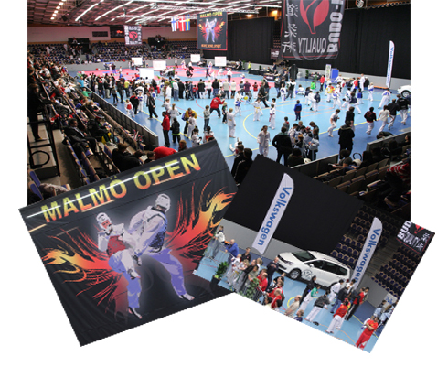

Start: Saturday the 26th of April 2014 08:30Am – ca: 19:00Pm

Arena: Baltiska Hallen, Eric Perssons väg, Malmoe

Requirements/Rules: Beginners: 9 gup - 5 gup
Advanced: 4 gup –
WTF Competition rules
Electronic vests only for juniors, seniors and advanced
The organizers only provides electronic vests
Competitors must show valid Taekwondo Pass and ID.

Age: Miniors: girls/boys born 2003-2007 (Mand. ID check)
Cadets: girls/boys born 2000-2002 (Mand. ID check)
Juniors: Men/women born 1997-2000 (Mand. ID check)
Seniors: Men/women born 1998 or earlier- (Mand. ID check)

Weight classes:
Miniors Men/Women | -26 | -28 | -30 | -32 | -34 | -38 | -42 | -46 | -50 | -54 | -57 | +57
Cadet Men | -33 | -37 | -41 | -45 | -49 | -53 | -57 | -61 | -65 | +65
Cadet Women | -29 | -33 | -37 | -41 | -44 | -47 | -51 | -55 | -59 | +59
Jun. Men | -45 | -48 | -51 | -55 | -59 | -63 | -68 | -73 | -78 | +78
Jun. Women | -42 | -44 | -46 | -49 | -52 | -55 | -59 | -63 | -68 | +68
Seniors Men | -54 | -58 | -63 | -68 | -74 | -80 | -87 | +87
Seniors Women | -46 | -49 | -53 | -57 | -62 | -67 | -73 | +73

Weighing in/Registr. Friday April 25th 17:00 – 20:00 in Baltiska Hallen.
Eric Perssons Väg, Malmoe and in Denmark ( more information will follow).

Two attempts only!

Change of weight class on site: 300 SEK

Match time: All Minors/Cadets 2 x 1,5 min
Beginners Juniors/Seniors 2 x 2 min
Advanced Juniors/Seniors 2 x 2 min

Trophies: Gold, Silver, Bronze, Best Fighter, Best Club 1-3 and diplomas to all participants.

Entry to competition: Must be made by Friday, April 18th

Any changes after April 18th will cost 300SEK per participant
Sign up via http://www.tpss.nl
Registration is binding/no refunds

Entry fee: Miniors/Cadets 300SEK
Juniors/Seniors 350SEK

To pay by bank transfers please use information below:
Bank name: Swedbank IBAN no: SE37 8000 0821 4997 3780 9088 SWIFT-BIC: SWEDSESS Account no: 8214-9, 973 780 908-8 Account holder: KFUK-KFUM Po-Eun KampsportCenter

No later than Friday, April 18th

Entrance: 70 SEK – 1 Coach per 5 participants for each club Maximum of 3 coaches per club with free admission

Draw: The draw is made after weigh in and is published on www.po-eun.nu after 22:00.
The Organizer reserves the right to move participants at the lack of opponents.

Referee: Interested referees please contact. Reza Abrishami
E-mail: reza.abrishami@telia.com
cellphone: +46 (0)707-68 48 40

Information: Patrick Karlsson, cellphone: +46 (0)707-171910, patrick@po-eun.nu Mohamed Wail, cellphone: +46(0)704-920353, mommo@po-eun.nu

INVITATION FOR POOMSAE

Date/Time: 26/4 2014 08:30
Location: Baltiska Hallen Eric Perssons Väg, Malmoe
Competitors entry: Advanced/Elite
No later than Friday April 15th at http://www.tpss.nl
Or via mail: laban@wtkd.se
Beginners/try-outs
Via mail: laban@wtkd.se and copy to sibbatorp@yahoo.se
Entry fee: Miniors/Cadets 300SEK
Juniors/Seniors 350kr

To pay by bank transfers please use information below:
Bankname: Swedbank IBAN no: SE37 8000 0821 4997 3780 9088 SWIFT-BIC: SWEDSESS Account no: 8214-9, 973 780 908-8 Account holder: KFUK-KFUM Po-Eun KampsportCenter

No later than Monday, April 17?^{th}

Registration is binding and the fee is non-refundable

Questions: patrick@po-eun.nu
Poomsae Questions: Peter Malmberg
070- 713 49 50, Mail:
peter.malmberg@samurang.se
Rules: WTF/STF.
Coach: One coach per every 5 participants (Maximum 3 coaches) .
Grad req./classes: Beginners 9-5 Gup
Try-Out 4 Gup-
Advanced 4 Gup- 1 Gup
Elite Dan/Poom

Beginnerclass (9-5 Gup)
Competing individually with any Taegyuk in each round (T1-T8). This means that a 9 Gup practitioners can do Taegyuk 1, three times - one for each round.
Try-Out class (4 Gup-)
Competing individually with any Taegyuk (T1-T8) / Poomsae (P1-P8) in each round. The practitioner can make the same pattern in each round.
Advanced class (4-1 Gup).
WTF / STF standard levels. advanced Class red belt 4-1gup. See Table 1
Elite Class Dan / Poom. WTF / STF standard levels. Elite Class Dan / Poom. See Table 2
Registration: Registration takes place in the arena 8:00 on the day of comp.
Taekwondo pass is mandatory along with ID!
Comp. start: First class is expected to start 09:00.
Prizes will be awarded as soon as the competition is complete

Divisions according to sex and age.

Children division (-13 years of age). All classes
Excepted from gender classification.
Below 17 division (14-17 years of age). All Classes
Men individual/ Women individual.
Below 29 division (18-29 years of age). All Classes
Men individual/women individual.
Below 39 division (30-39 years of age). All Classes
Men individual/ women individual.
Below 49 division (40-49 years of age). All classes
Men individual/ women individual.
Below 59 division (50-59 years of age). All Classes
Men individual/ women individual.
Above 59 division (60+ years of age). All Classes
Men individual/ women individual.

Pair division is divided as follows: Only Adv. Class/Elite class
Pair (2 persons, 1 of each).
Pair below 29, 14 – 29 years of age.
Pair above 29, from 30 years of age.

Team division broken down as follows: Only Advanced Class / Elite Class

Team men (3 men).
Team women (3 women).
Team men below 29, 14 – 29 years of age.
Team Men over 29, from 30 years of age.
Team Women over 29, from 30 years of age.
NOTE! Classes may be combined depending on number of participants.
The organizer can at any time change classes if WTF/STF makes changes.

Poomsae table 1, Advanced; Red belt 4-1 gup
Division | Table 1 | Table 2
Children (-13 years of age) | 4gup: T4 | 4gup: T5 eller T6
 | 3gup: T5 | 3gup: T6 eller T7
 | 2gup: T6 | 2gup: T7 eller T8
 | 1gup: T6 | 1gup: T7 eller T8
Below 17 (14-17 years of age) | 4gup: T4 | 4gup: T5 eller T6
 | 3gup: T5 | 3gup: T6 eller T7
 | 2gup: T6 | 2gup: T7 eller T8
 | 1gup: T6 | 1gup: T7 eller T8
Below 29 (18-29 years of age) | 4gup: T4 | 4gup: T5 eller T6
 | 3gup: T5 | 3gup: T6 eller T7
 | 2gup: T6 | 2gup: T7 eller T8
 | 1gup: T6 | 1gup: T7 eller T8
Below 39, Below 49, Below 59, Above 59 (From 30 years of age and up) | 4gup: T4 | 4gup: T5 eller T6
 | 3gup: T5 | 3gup: T6 eller T7
 | 2gup: T6 | 2gup: T7 eller T8
 | 1gup: T6 | 1gup: T7 eller T8
Pair (women/Men)* | See explanation below | See explanation below
Team (Three of the same sex)* | See explanation below | See explanation below
For pairs and teams one Taeguck is carried out in Semifinals and two Taeguck in the final round, which Taeguck that should be carried out is decided by the Taeguck the lowest graded member in the pair/team has in the individual scale.
Example: Pair-29 consists of 1 participant 14-17 years of age 2 Gup and one participant 18-29 years of age 4 Gup.
According to the individual scale the first competitioner shall execute T6 in the semi and T7-T8 in the finals, the other competitioner shall perform T4 in the semi and T5-T6 in the finals. Thus they attend as a PAIR in the Semi T4 and Final T5-T6

Poomsae Table 2, Elite;
from 1dan/1poom
Division | Table
Children (-13 years of age) (Not national teams) | T4 – Taeback
Below 17 (14-17 years of age) | T4 – Taeback
Below 29 (18-29 years of age) | T6 – Shipjin
Below 39 (30-39 years of age) | T6 – Shipjin
Below 49 (40-49 years of age) | T8 – Chonkwon
Below 59 and Över 59 | Koryo – Hansu
Pair below 29 (14-29 years of age(Women/Men) | T6 – Shipjin
Pair over 29 (Women/Men) | T8 – Chonkwon
Team 1 | T6 – Shipjin
Team 2 | T8 – Chonkwon

NOTE! Draw of which poomsae that shall be performed in the elite class is carried out 1 day before competition start. Which Taeguck/Poomsae that shall be performed is published in the arena before competition start.
Organizers:
KFUM Po-Eun Kampsportcenter
Swedish Taekwondo federation

